Lab Assignment #6
Natural Frequency and Mode Shapes

EAE 133 - Finite Element Methods in Structures
Professor N. Sarigul-Klijn
TA: Noah Derita

Aurian Malhotra
920005606
Section A04, 11/6/2025

Introduction
The purpose of this lab was to compute the natural frequencies and corresponding mode shapes of a lifting-surface structure modeled as a cantilever beam. While the physical model was simplified into a one-dimensional BAR2 element formulation, the free-vibration problem still captures the essential bending and torsional modes present in real lifting surfaces. The beam was constructed from material and geometric properties listed in Table 1, including an elastic modulus of 10,000,000 psi, a density of 5.24 slug/ft³, and a rectangular cross-section measuring 3 in by 1.9 in. The root was fully constrained to simulate a cantilever condition, and the tip remained free, allowing the structure to deform according to its inherent dynamic characteristics. The analysis focused on determining the first five natural frequencies and verifying mesh convergence by repeating the modal analysis using 10, 20, and 40 elements. The converged mesh was then used to identify the physical nature of each vibration mode.

Table 1: Problem Data
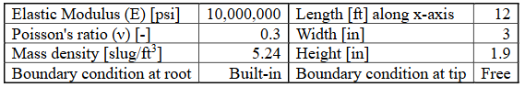

Procedure
The model was generated in Patran using a single line of length 12 ft (144 in) along the x-axis, representing the span of the cantilever beam. A rectangular cross-section with the specified width and height from Table 1 was created in the Beam Library, and an isotropic material was defined using the given Young’s modulus, density, and Poisson ratio. A 1D BAR2 property was then assigned to the curve and the root condition was applied by constraining all translational and rotational degrees of freedom of the node at x = 0 in. Since the analysis required natural frequencies, the solution type was switched to Normal Modes, and the mass formulation was changed from lumped to coupled. Because the model used inches for cross-sectional dimensions, the weight-to-mass conversion factor was adjusted to 1/12 per the guide.

A convergence study was performed by generating three separate uniform meshes consisting of 10, 20, and 40 elements. For each mesh, the old seed and mesh were deleted before applying the new seed assignment. Five roots were requested in the subcase parameters to extract the first five natural frequencies for every mesh. After solving the 40-element case, the fringe width was increased to maximum thickness, and translational eigenvectors were selected for both Fringe and Deformation attributes. Finally, screenshots of all five mode shapes were recorded for the converged mesh.
Results

Figure 1: First Flap-Wise
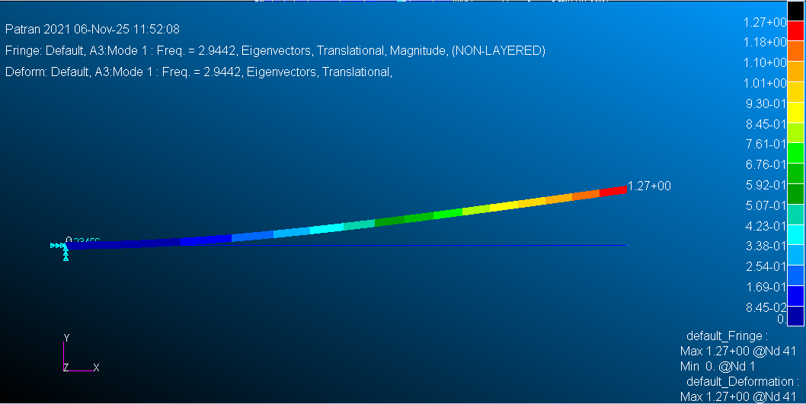

Mode 1 (≈ 2.94 Hz): This mode is the first flap-wise bending mode. The beam bends primarily in the vertical direction with the largest displacement at the free tip and zero motion at the root, giving a smooth, single-curvature shape along the span.

Figure 2: First in-Plane
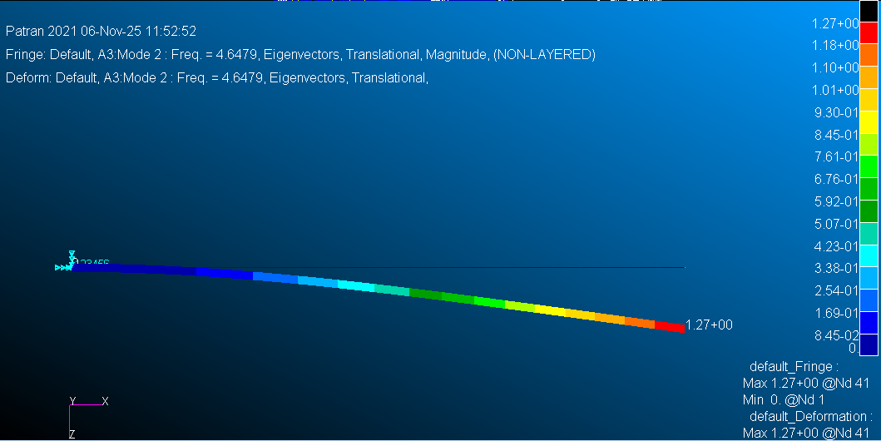

Mode 2 (≈ 4.65 Hz): This mode is the first in-plane (axial) bending mode. The beam deflects mainly in the horizontal plane, again with maximum motion at the tip. The shape is similar to Mode 1, but the motion is aligned more with the beam axis rather than purely vertical bending.

Figure 3: Second Flap-Wise
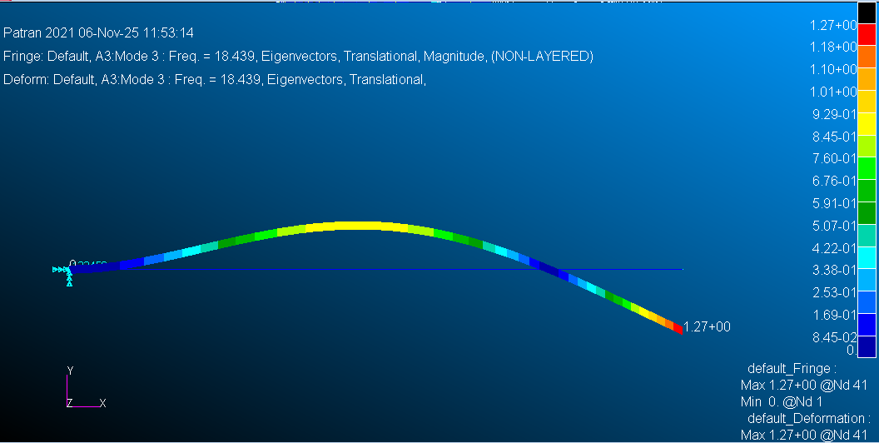

Mode 3 (≈ 18.44 Hz): This mode is the second flap-wise bending mode. The beam still bends vertically, but now there is one internal point along the span where the displacement changes sign (a node). This gives a “two-curvature” shape, showing a higher-order bending pattern than Mode 1.

Figure 4: First Torsion
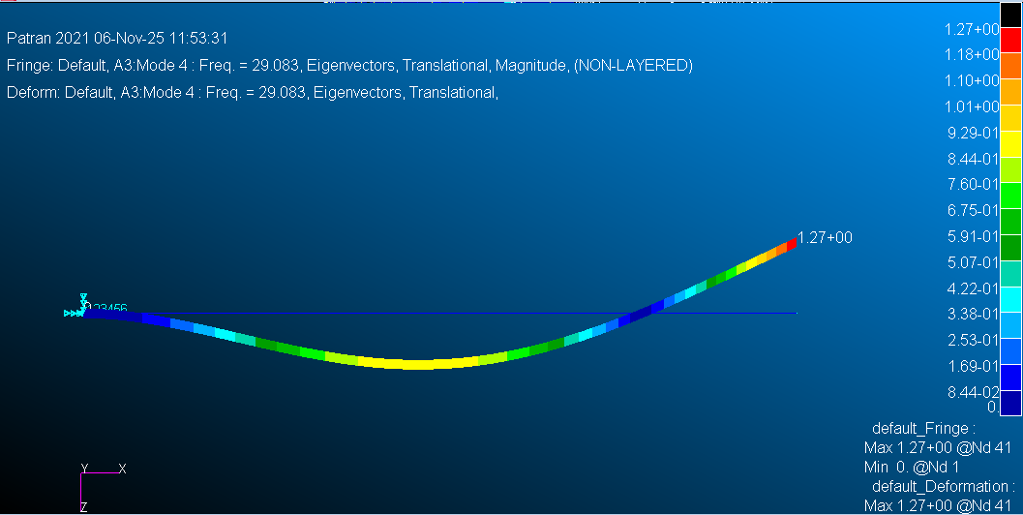

Mode 4 (≈ 29.08 Hz): This mode is the first torsional mode. Instead of mainly translating, the cross-section twists about the beam’s longitudinal axis so that the top and bottom of the beam rotate in opposite directions. Overall vertical translation is smaller compared to the bending modes.
Figure 5: Third Flap-Wise
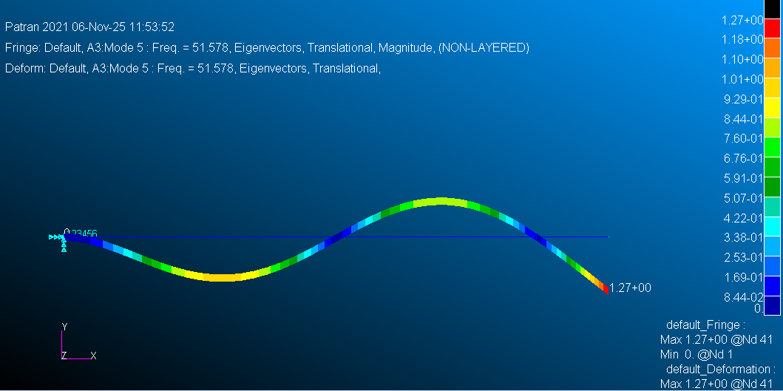

Mode 5 (≈ 51.58 Hz): This mode is the third flap-wise bending mode. The beam shows two internal nodes and three bending “lobes,” meaning the shape alternates up and down along the span. This is a higher-frequency continuation of the flap-wise bending behavior seen in Modes 1 and 3.

Table 2: Natural Frequencies (Hz) of First Five Modes For Increasing Element Size
Element Size | Mode 1 | Mode 2 | Mode 3 | Mode 4 | Mode 5
10 | 2.944153E+00 | 4.647935E+00 | 1.843980E+01 | 2.908391E+01 | 5.159292E+01
20 | 2.944151E+00 | 4.647930E+00 | 1.843916E+01 | 2.908272E+01 | 5.157912E+01
40 | 2.944150E+00 | 4.647930E+00 | 1.843910E+01 | 2.908259E+01 | 5.157792E+01

Figure 6: Convergence Plot (Natural Frequency vs. Element Size)
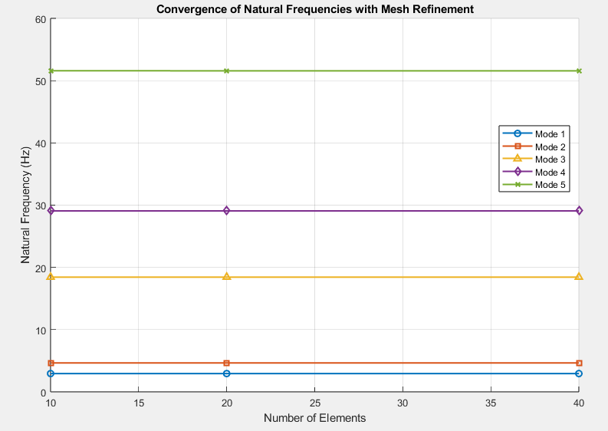

Discussion/Conclusion
The results of this lab provide a clear demonstration of how a cantilever beam responds dynamically when modeled using finite elements. The first mode occurs at the lowest frequency because it represents the simplest form of deformation: a smooth flap-wise bending of the beam. Higher modes show increasingly complex shapes, such as in-plane bending, additional bending lobes, and twisting of the section about its longitudinal axis. Each added feature in the mode shape corresponds to a stiffer type of deformation, which is why the associated frequencies increase.

The convergence study illustrates why mesh refinement matters in modal analysis. With only 10 elements, the frequencies are already reasonably close to the more refined solutions, but small discrepancies still appear, especially in the higher modes where curvature changes are sharper. When the mesh is increased to 20 and 40 elements, the frequencies change only slightly, indicating that the solution has stabilized. This behavior shows that the finite element model becomes more accurate as element size decreases, but after a certain point (here around 20 - 40 elements), additional refinement does not significantly change the results.

Overall, the lab successfully demonstrates the basic dynamic characteristics of a cantilevered lifting surface using 1D BAR2 elements. The ordering of the modes (flap-wise, in-plane, higher-order bending, and torsion) matches what we physically expect from a beam under cantilever constraints, and the numerical convergence increases our confidence in the obtained results.

References
chatgpt.com
- We haven’t had our last three lectures, so we haven’t learned this yet. I used chat briefly to understand what I was looking at with my data and how to interpret it.

